
NOTE: This is an official document by Indexademics. Unless otherwise stated, this document may not be accredited to individuals or groups other than the club IDX, nor should this document be distributed, sold, or modified for personal use in any way.
IDX G9 Computer Science H STUDY GUIDE ISSUE 8
By Iris 9-2 and Gavin 9-4, Edited by Ziyu 9-11

Web Scraping
- extracting data from websites in an automated manner
- collects the unstructured data from the websites and stores it in a structured form
- Features
  - Implicit politeness
    - avoid hitting any site too often, may lead to denail to service
  - Explicit politeness
    - use robots.txt file to indicate which parts of the site should not be accessed by web crawlers and crawler must always adhere to it
  - Robustness
    - Crawler should be immune to malicious behaviors of web servers
- Robots Exclusion Protocol (REP)
  - a standard that regulates web robot behavior and tells whether a website allows web scraping or not
  - find website’s REF by appending “/robots.txt” to the URL
- process of web scraping
  - Send HTTP request to get response
  - Parse the web data
  - Extract the data
  - Store the data
  - Visualization
- Vocabs
  - Domain name
    - identify a particular computer on the Internet
    - computers convert domain name to IP address for it to be readable
  - IP address
    - Internet Protocol address
    - a number used to indicate the location of a computer on a network
  - Transmission Control Protocol (TCP)
    - Establishes a connection between sender and receiver and ensures data is delivered accurately and in order
  - Internet Protocol (IP)
    - Defines how data is addressed and routed between devices on a network
  - Domain Name System (DNS)
    - translates human-readable domain names into IP addresses, which computers use to locate and communicate with each other.
Requests
- res = requests.get(url, headers = headers)
  - res.status_code – integer showing whether its accessible
    - 200 - The request has succeeded.
    - 403 - The client does not have access rights to the content.
    - 404 - The server cannot find the requested resource.
  - res.text – string data
  - res.content – binary data
  - res.encoding – return webpage encoding
- res = requests.post(url, json = json, headers = headers)
Beautiful Soup
- soup = bs4.BeautifulSoup(res.text, 'html.parser')
  - ‘html.parser’ – build in function
- soup = bs4.BeautifulSoup(res.text, ‘lxml') # pip install lxml
Document Object Model (DOM)
- Document Object Model (DOM) defines the logical tree structure of the website.
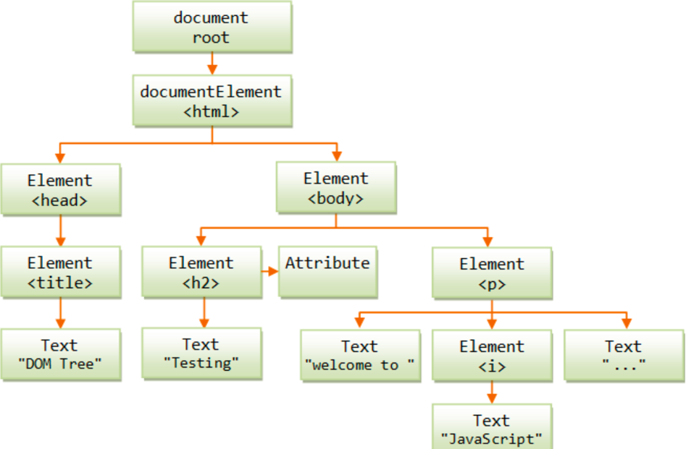
- The browsers, such as Chrome, Firefox, Safari can conduct web scraping using the DOM parsing method.

CSS Selectors
- Generally select
  - soup.select(‘div’)
    - All elements named <div>
  - soup.select(‘div#author’)
    - All elements named <div> that use an id attribute named author
  - soup.select(‘div.notice’)
    - All elements named <div> that use a class attribute named notice
  - soup.select(‘div span’)
    - All elements named <span> that are within an element named <div>
  - soup.select(‘div > span’)
    - All elements named <span> that are directly within an element named <div>, with no other element in between
  - soup.select(‘input[name]’)
    - All elements named <input> that have a name attribute with any value
  - soup.select(‘input[type=“button”]’)
    - All elements named <input> that have an attribute named type with value button
  - soup.select(‘tag[attr=“val”]’)[0].getText()
    - get the inner text of the first element named tag with attribute attr and value val
  - soup.select(‘tag[attr=“val”]’)[0].get(‘href’)
    - get the attribute value of ‘href’ from the first element named tag with attribute attr and value val
- Get a specific attribute
  - soup.select(‘a’)[0][‘href’]
  - soup.select(‘a’)[0].get(‘href’)
  - soup.select(‘a’)[0].attrs[‘href’]
- Get the text value
  - soup.select(‘a’)[0].getText()
  - soup.select(‘a’)[0].text
Dynamic Webpage Loading
- when we browse the website, as we continue to scroll down the page, it will refresh the new content, but the URL on the browser has not changed
- JavaScript is used in this kind of dynamic loading page
  - interacts with HTML elements or nodes, manipulating them in response to user inputs, triggering visual feedback, dynamically updating content
  - deals with user interaction
- Application Programming Interfaces (APIs)
  - allow developers to create complex functionality more easily
- Benefits
  - Page updates are a lot quicker and you don't have to wait for the page to refresh, meaning that the site feels faster and more responsive.
  - Less data is downloaded on each update, meaning less wasted bandwidth.

JSON
- JavaScript Object Notation
- make a HTTP request to a server to retrieve specific resources, and the data requested is often JSON
  - a good format for transferring structured data
- In Python, JSON data is usually represented as a string
- In the early days, this dynamic loading technique was known as Asynchronous JavaScript and XML(Ajax), because it tended to request XML data. This is normally not the case these days.
- How to get JSON data
  - json_data = res.json()
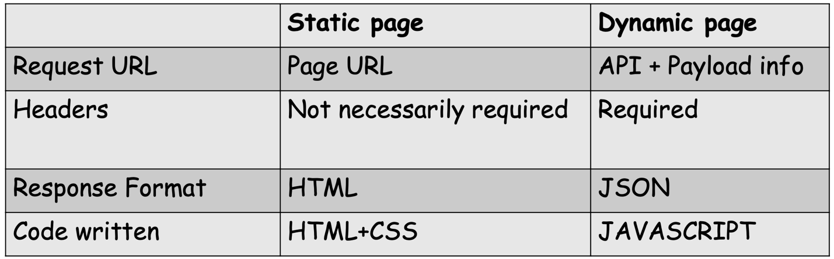
  - json_data = json.loads(res.text)

Web Scraping Example Code

Example HTML Structure
<!DOCTYPE html>
<html>
<head>
<title>Sample Page</title>
</head>
<body>
<!-- Text -->
<div id="content">
<h1>Welcome to Example.com</h1>
<p class="text">First paragraph of text.</p>
<p class="text">Second paragraph with a <a href="/page2">link</a>.</p>
</div>
<!-- Links -->
<div class="links">
<a href="https://example.com/page1">Page 1</a>
<a href="https://example.com/page2">Page 2</a>
</div>
<!-- Images -->
<div class="gallery">
<img src="image1.jpg" alt="Image 1">
<img src="image2.png" alt="Image 2">
</div>
<!-- Video (embedded via script) -->
<script name="video" src="video.mp4"></script>
<!-- Pagination -->
<div class="pagination">
<a href="/page1">1</a>
<a href="/page2">2</a>
<a href="/page3">3</a>
</div>
</body>
</html>

Code Examples

1. Retrieve Text from HTML
import requests
import bs4
url = "https://example.com"
res = requests.get(url)
soup = bs4.BeautifulSoup(res.text, 'html.parser')
# Extract all paragraphs with class "text"
text_elements = soup.select('p.text')
for p in text_elements:
print(p.getText())

2. Extract Links
# Extract all links (anchor tags)
links = soup.select('a')
for link in links:
link_url = link.get('href')
link_text = link.getText()
print(f"Link Text: {link_text}, URL: {link_url}")

3. Download Images
import os
# Create directory for images
if not os.path.exists('images'):
os.makedirs('images')
# Download all images
images = soup.select('img')
for img in images:
img_url = img['src']
res_img = requests.get(img_url)
with open(f'images/image_{idx}.jpg', 'wb') as f:
f.write(res_img.content)
print(f"Downloaded: {img_url}")
i += 1

4. Handle Videos
# Extract video URL from script tag
video_script = soup.select('script[name="video"]')[0]
video_url = video_script['src']
# Download video
res_video = requests.get(video_url)
with open('video.mp4', 'wb') as f:
f.write(res_video.content)
print("Video downloaded!")

5. Scrape Multiple Pages
base_url = "https://example.com/page"
# Scrape pages 1-3
for page in range(1, 4):
url = f"{base_url}{page}"
res = requests.get(url)
soup = bs4.BeautifulSoup(res.text, 'html.parser')
print(f"Scraping {url}...")
# Add your extraction logic here
titles = soup.select('h1')
for title in titles:
print(title.getText())

Key Concepts
- HTTP Requests: Use `requests.get()` to fetch HTML content.
- Parsing: Use `BeautifulSoup` to parse HTML with `html.parser` or `lxml`.
- Selectors:
- `soup.select('tag.class')` for class-based selection.
- `soup.select('tag#id')` for ID-based selection.
- Ethical Scraping:
- Check `robots.txt` (e.g., `https://example.com/robots.txt`).
- Add delays with `time.sleep(2)` to avoid overloading servers.

